Variables
A variable stores data that can be changed later on. Project with Flow support can have both global and local variables. Global variables are visible from all Flows, local variables are visible only inside the Flow in which it is defined.

Project without Flow support can have only global variables and those variables must be Native i.e. variables managed by the native code (written in C++).

To add variables, use the Variables panel (Fig. 1), when a dialog box will open for defining the basic parameters of the variable (Name, Type and Default value).

To edit the parameters of the variable selected in the Variables panel, use the Properties panel. In Fig. 2, Fig. 3 and Fig. 4 shows Properties panels for different types of variables from different types of projects.

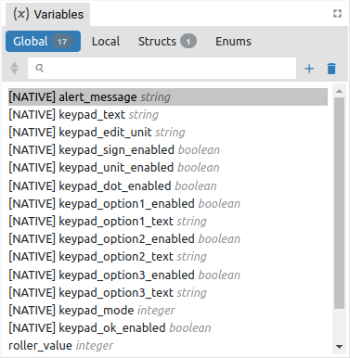Fig. 1: Variables panel | 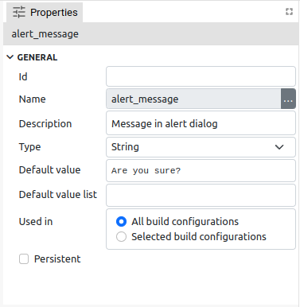Fig. 2: Variable Properties panel (EEZ-GUI)

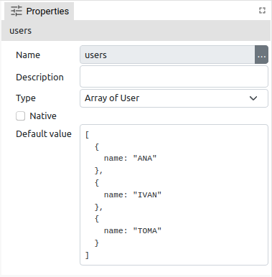Fig. 3: Variable Properties panel (LVGL) | 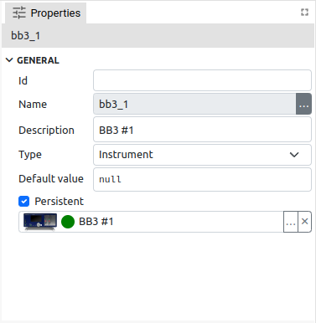Fig. 4: Variable Properties panel (Dashboard)

Item | Description
Id | ID is EEZ-GUI project specific and is used in Page, Action, Global Variable, Style, Font, Bitmap and Colors. These are all resources that are referenced by name in the project editor. When that project is built, names are no longer used, but numerical IDs. This field is optional, i.e. an ID does not have to be specified, in which case an ID will be assigned during the build. However, if we want an object to always get the same ID, then it needs to be defined. Why would we want to always have the same ID? This is necessary when there is a master project such as modular-psu-firmware.eez-project from EEZ BB3 and that master project is used by BB3 Applets and BB3 MicroPython scripts and they can use resources from the master project that have that ID defined.  Important: once the ID is set, it should not be changed, otherwise all BB3 scripts that depend on it should be rebuilt.
Name | Variable is referenced in other parts of project by its name.  Rules for naming variables: Starts with a letter or an underscore (_), followed by zero or more letters, digits, or underscores. Spaces are not allowed.
Description | Optional field, contains a description of the variable.
Type | The type of data stored in variable. When adding a new variable, its suggested default value will depend on the selected type (0 for Integer, False for Boolean, etc.).
Native | The variable is managed by the native code (written in C++).  A Dashboard project cannot have Native variables, and working with them is explained in Chapter XX.
Default value | Default value is the initial value of the variable when Flow starts. Given in JSON notation (https://www.json.org/json-en.html).  For example: 123, "Hello", true  If types is struct: { "member1": 42, "member2": "Hello" }  If type is array: [1, 2, 3] or ["string1", "string2", "string3"]
Default value list | Only supported in EEZ-GUI project that does not have EEZ Flow enabled.
Used in | See Configurations in project Settings.
Persistent (Global variables only) | Stores the last value of the variable in the .eez-runtime-settings file, so that next time projects will have this value, instead of the default value.  Supported only in Dashboard projects.

Variables usage
Variables are used in the project with EEZ Flow enabled. Data stored in a variable can be accessed using expressions. The following Action components are used to work with variables:
- Evaluate – evaluates expression, which can use variables, and sends the result through "result" data line.
- Watch – monitors the change in the value of the variable. At Flow start, it always sends the current value via the Changed data flow line, and later every value change is sent.
- SetVariable – sets a new variable value. Multiple entries are allowed. Each entry contains a variable and an expression field. During Flow execution, the evaluated expression will be stored in a variable.
- SwitchCase, Compare, IsTrue – Actions used for branching in the Flow depending on the value of the variable
Variables are also used in Widget components. Certain Widget properties can be defined as an expression. In this case, the value of that property will change during Flow execution as the expression changes. For example, Label widget can show the content of some variable, and it will updated every time this variable has been modified.

Variable types

Basic/Primitive types
Item | Description
Integer | Signed 32-bit integer.
Float | IEEE 4-byte floating-point.
Double | IEEE 8-byte floating-point.
Boolean | Can hold true of false value.
String | Sequence of characters.
Date | Unix timestamp.
Blob | Binary large object (Dashboard projects only).
Stream | Stream of data (Dashboard projects only).
Any | Can hold any data type.

Structures
Structure types are defined in Variables panel in Structs section. Struct type variable stores multiple data values each accessed by its member name. Each member is defined by its name and type.

Structures can only be used in projects that have EEZ Flow enabled.

Enums
Enums types are defined in Variables panel in Enums section. Enum type variable stores integer data value, but can contain only restricted set of values. Each enum member is defined by its name and integer value.

Objects
Object variables, similar to structs, can hold multiple values, each accessed by member names. The member names depends of the type of Object variable. Example of object variables: Instrument connection or PostgreSQL connection. Object variables are described in more detail in Chapter XX.

Object variables can only be used in Dashboard projects.

Arrays
Array variable stores multiple data values.

Expressions
An expression contains instructions on how to evaluate a data value during Flow execution. An expression is defined in code similar to JavaScript or other C-like languages.

Expression element | Description / Example
Literal value | Example: 42, "Hello", true
Variable names | Example: my_var
Input names | Retrieves the data stored in data input using the name of that input.  Example: input_name
Binary operator | Example: my_integer_var + 1
Logical operator | Example: my_integer_var < 10
Unary operator | Example: -my_integer_var
Ternary operator | Example: my_integer_var == 1 ? true : false  (evaluates to True if my_integer_var is 1, otherwise evaluates to False)
Function calls | Example: String.length(my_string_var)
Parentheses “()” | Specifying the order of the evaluation  Example: "Counter: " + (a + 1)
Accessor “.” | Structure type member accessor by using “.”  Example: my_struct_var.member1
Accessor “[]” | Array element accessor by using “[]”  Example: my_array_var[3], my_array_var[index]
Enum value | Example: MyEnumTypeName.Member1

Expression examples:

`var[i].member1`
`var` is array which contains structs, which has member `member1`
`i` is integer variable
evaluates to `member1` value in the i-th element
`var == State.START || var == State.EMPTY`
var is of type enum:State, and State enum has two members: START and EMPTY
evaluates to True if var contains data that is either State.START or State.EMPTY

Literals
Type | Description / Example
Integer | `42`
Float or double | `3.14`
String | `"Hello world!"`
Translated string | T"text_resource_id" (prefix T is mandatory)
Boolean | `true` or `false`
JSON | See https://www.json.org/json-en.html

Binary Operators
Each binary operators requires two arguments. Binary operator is written between arguments, for example: <arg1> + <arg2>

+ Addition

Rules:
- If any of the arguments is a string then result is a string. For example, `voltage +" V"` will evaluate to `"1.5 V"` if data stored in voltage variable is `1.5`
- If any of the arguments is a double then result is a double.
- If one argument is a float and the other is a float or an integer the result will be a float.
- If both arguments are integers then result is an integer.

arg1\arg2 | integer | float | double | string | boolean | other_type
integer | integer | float | double | string | integer | err
double | double | double | double | string | double | err
float | float | float | double | string | float | err
string | string | string | string | string | string | err
boolean | integer | float | double | string | integer | err
other_type | err | err | err | err | err | err

Subtraction -

arg1\arg2 | integer | float | double | boolean | other_type
integer | integer | float | double | integer | err
double | double | double | double | double | err
float | float | float | double | float | err
boolean | integer | float | double | integer | err
other_type | err | err | err | err | err

Multiplication *

arg1\arg2 | integer | float | double | boolean | other_type
integer | integer | float | double | integer | err
double | double | double | double | double | err
float | float | float | double | float | err
boolean | integer | float | double | integer | err
other_type | err | err | err | err | err

Division /

arg1\arg2 | integer | float | double | boolean | other_type
integer | integer | float | double | integer | err
double | double | double | double | double | err
float | float | float | double | float | err
boolean | double | float | double | double | err
other_type | err | err | err | err | err

Remainder %

arg1\arg2 | integer | float | double | boolean | other_type
integer | integer | float | double | integer | err
double | double | double | double | double | err
float | float | float | double | float | err
boolean | integer | float | double | integer | err
other_type | err | err | err | err | err

Left shift <<

arg1\arg2 | integer | boolean | other_type
integer | integer | integer | err
boolean | integer | integer | err
other_type | err | err | err

Right shift >>

arg1\arg2 | integer | boolean | other_type
integer | integer | integer | err
boolean | integer | integer | err
other_type | err | err | err

Binary AND &

arg1\arg2 | integer | boolean | other_type
integer | integer | integer | err
boolean | integer | integer | err
other_type | err | err | err

Binary OR |

arg1\arg2 | integer | boolean | other_type
integer | integer | integer | err
boolean | integer | integer | err
other_type | err | err | err

Binary XOR ^

arg1\arg2 | integer | boolean | other_type
integer | integer | integer | err
boolean | integer | integer | err
other_type | err | err | err

Logical operators
Logical operators are also binary operators that result in Boolean values.

Type | Description
==
!=
<
>
<=
>=
&&
||

Unary operators
Type | Description
+
-
~
!

Conditional (ternary) operator
The conditional (ternary) operator is the only operator that takes three operands: a condition followed by a question mark (?), an expression to be executed if the condition is true followed by a colon (:), and finally an expression to be executed if the condition is false.

Functions

System
System.getTick
Description: | Retrieves the number of milliseconds that have elapsed since the flow execution was started.
Parameters: | None
Return value: | Type: Integer
 | Description: Value in milliseconds.

Flow
Flow.index
Description: | Index of current element in the List and Grid widget. Check the description of these two widget for the more information.
Parameters: | Name: index
 | Type: Integer
 | Description: ???
Return value: | Type: Integer
 | Description: Element index.

Flow.isPageActive
Description: | If this function is executed inside the page it will return true if that page is currently active page, otherwise it will return false.
Parameters: | None
Return value: | Type: Boolean
 | Description: True if page is active, False if page is not active.

Flow.pageTimelinePosition
Description: | If this function is executed inside the page or custom widget it will return the current position at the animation timeline for that page or custom widget.
Parameters: | None
Return value: | Type: Boolean
 | Description: Timeline position.

Flow.makeValue
Description: | Creates a new value of type Struct.
Parameters: | Name: structName | Type: String | Description: Structure name.
 | Name: value | Type: JSON | Description: Structure value.
Return value: | Type: Struct
 | Description: Created struct value.

Flow.makeArrayValue
Description: | Creates a new value of type array.
Parameters: | Name: value
 | Type: JSON
 | Description: Array value.
Return value: | Type: Array
 | Description: Created array value.

Flow.languages
Description: | Retrieves a list of languages defined in multi-language project as array of strings.
Parameters: | None
Return value: | Type: Array:string
 | Description: Array of languages.

Flow.translate
Description: | Translate text resource ID, same as T"textResourceID".
Parameters: | Name: textResourceID
 | Type: String
 | Description: Text resource ID.
Return value: | Type: String
 | Description: Translated string.

Flow.parseInteger
Description: | Parse integer value given as string.
Parameters: | Name: str
 | Type: String
 | Description: Input string.
Return value: | Type: Integer
 | Description: Parsed integer value.

Flow.parseFloat
Description: | Parse float value given as string.
Parameters: | Name: str
 | Type: String
 | Description: Input string.
Return value: | Type: Float
 | Description: Parsed float value.

Flow.parseDouble
Description: | Parse double value give as string.
Parameters: | Name: str
 | Type: String
 | Description: Input string.
Return value: | Type: Double
 | Description: Parsed double value.

Date
Date.now
Description: | Returns current date.
Parameters: | None
Return value: | Type: Now
 | Description: Current datetime.

Date.toString
Description: | Converts given date to string.
Parameters: | str date
 | Type: Date
 | Description: Input date.
Return value: | Type: String
 | Description: Date string.

Date.toLocaleString
Description: | Converts given date to locale string.
Parameters: | str date
 | Type: Date
 | Description: Input date.
Return value: | Type: String
 | Description: Date string.

Date.fromString
Description: | Converts string to date.
Parameters: | Name: dateStr
 | Type: String
 | Description: Input string.
Return value: | Type: Date
 | Description: Date

Date.getYear
Description: | Get year from date.
Parameters: | Name: date
 | Type: Date
 | Description: Input date.
Return value: | Type: Integer
 | Description: Year

Date.getMonth
Description: | Get month from date (1 to 12).
Parameters: | Name: date
 | Type: Date
 | Description: Input date.
Return value: | Type: Integer
 | Description: Year

Date.getDay
Description: | Get day of the month from date (1 to 31).
Parameters: | Name: date
 | Type: Date
 | Description: Input date.
Return value: | Type: Integer
 | Description: Day

Date.getHours
Description: | Get hours from date (0 to 23).
Parameters: | Name: date
 | Type: Date
 | Description: Input date.
Return value: | Type: Integer
 | Description: Hours

Date.getMinutes
Description: | Get minutes from date (0 to 59).
Parameters: | Name: date
 | Type: Date
 | Description: Input date.
Return value: | Type: Integer
 | Description: Minutes

Date.getSeconds
Description: | Get seconds from date (0 to 59).
Parameters: | Name: date
 | Type: Date
 | Description: Input date.
Return value: | Type: Integer
 | Description: Seconds

Date.getMilliseconds
Description: | Get milliseconds from date (0 to 999).
Parameters: | Name: date
 | Type: date
 | Description: Input date.
Return value: | Type: Integer
 | Description: Milliseconds

Date.make
Description: | Make a date from arguments.
Parameters: | Name: year | Type: Integer | Description: Year
 | Name: month | Type: Integer | Description: Month
 | Name: day | Type: Integer | Description: Day
 | Name: hours | Type: Integer | Description: Hours
 | Name: minutes | Type: Integer | Description: Minutes
 | Name: seconds | Type: Integer | Description: Seconds
 | Name: milliseconds | Type: Integer | Description: Milliseconds
Return value: | Type: Date
 | Description: Constructed date.

Math
Math.sin
Description: | Returns the sine of a number in radians.
Parameters: | Name: x
 | Type: Integer|Float|Double.
 | Description: A number representing an angle in radians.
Return value: | Type: Float|Double
 | Description: The sine of x, between -1 and 1, inclusive.

Math.cos
Description: | Returns the cosine of a number in radians.
Parameters: | Name: x
 | Type: Integer|Float|Double
 | Description: A number representing an angle in radians.
Return value: | Type: Float|Double
 | Description: The cosine of x, between -1 and 1, inclusive.

Math.pow
Description: | Returns the value of a base raised to a power.
Parameters: | Name: base | Type: Integer|Float|Double | Description: The base number.
 | Name: exponent | Type: Integer|Float|Double | Description: The exponent number.
Return value: | Type: Float|Double
 | Description: A number representing base taken to the power of exponent.

Math.log
Description: | Returns the natural logarithm (base e) of a number.
Parameters: | Name: x
 | Type: Integer|Float|Double
 | Description: A number greater than or equal to 0.
Return value: | Type: Float|Double
 | Description: The natural logarithm (base e) of x.

Math.log10
Description: | Returns the base 10 logarithm of a number.
Parameters: | Name: x
 | Type: Integer|Float|Double
 | Description: A number greater than or equal to 0.
Return value: | Type: Float|Double
 | Description: The base 10 logarithm of x.

Math.abs
Description: | Returns the absolute value of a number.
Parameters: | Name: x
 | Type: Integer|Float|Double
 | Description: A number.
Return value: | Type: Integer|Float|Double
 | Description: The absolute value of x. If x is negative (including -0), returns -x. Otherwise, returns x. The result is therefore always a positive number or 0.

Math.floor
Description: | Always rounds down and returns the largest integer less than or equal to a given number.
Parameters: | Name: x
 | Type: Integer|Float|Double
 | Description: A number.
Return value: | Type: Integer|Float|Double
Description: The largest integer smaller than or equal to x.
It’s the same value as -Math.ceil(-x).

Math.ceil
Description: | Always rounds up and returns the smaller integer greater than or equal to a given number.
Parameters: | Name: x
 | Type: Integer|Float|Double
 | Description: A number.
Return value: | Type: Integer|Float|Double
Description: The smallest integer greater than or equal to x.
It’s the same value as -Math.floor(-x).

Math.round
Description: | Returns the value of a number rounded to the nearest integer.
Parameters: | Name: value
 | Type: Integer|Float|Double
 | Description: A number.
Return value: | Type: Integer|Float|Double
 | Description: The value of x rounded to the nearest integer.

Math.min
Description: | Returns the smallest of the numbers given as input parameters.
Parameters: | Name: value1, …, valueN
 | Type: Integer|Float|Double
 | Description: Zero or more numbers among which the lowest value will be selected and returned.
Return value: | Type: Integer|Float|Double
 | Description: The smallest of the given numbers.

Math.max
Description: | Returns the largest of the numbers given as input parameters.
Parameters: | Name: value1, …, valueN
 | Type: Integer|Float|Double
 | Description: Zero or more numbers among which the largest value will be selected and returned.
Return value: | Type: Integer|Float|Double
 | Description: The largest of the given numbers.

String
String.length
Description: | Returns the length of the string.
Parameters: | Name: string
 | Type: String
 | Description: A string.
Return value: | Type: Integer
 | Description: The length of a string.

String.substring
Description: | Returns the part of the string from the start index up to and excluding the end index, or to the end of the string if no end index is supplied.
Parameters: | Name: string |  | Type: String | Description: A string.
 | Name: start |  | Type: String | Description: The index of the first character to include in the returned substring.
 | Name: end | Optional: Yes | Type: String | Description: The index of the first character to exclude from the returned substring.
Return value: | Type: String
 | Description: A new string containing the specified part of the given string.

String.find
Description: | Searches a string and returns the index of the first occurrence of the specified substring.
Parameters: | Name: string | Type: String | Description: A string.
 | Name: substring | Type: String | Description: Substring to search for.
Return value: | Type: String
 | Description: The index of the first occurrence of substring found, or -1 if not found.

String.padStart
Description: | Pads the current string with another string (multiple times, if needed) until the resulting string reaches the given length.
Parameters: | Name: string | Type: String | Description: A string.
 | Name: targetLength | Type: Integer | Description: The length of the resulting string once the current str has been padded. If the value is less than or equal to str.length, then str is returned as-is.
 | Name: padString | Type: String | Description: The string to pad the current str with. If padString is too long to stay within the targetLength, it will be truncated from the end.
Return value: | Type: String
 | Description: A String of the specified targetLength with padString applied from the start.

String.split
Description: | Takes a separator parameter and divides a String into an ordered list of substrings by searching for the separator pattern, puts these substrings into an array, and returns the array.
Parameters: | Name: string | Type: String | Description: A string.
 | Name: separator | Type: Integer | Description: The pattern describing where each split should occur.
Return value: | Type: array:string
 | Description: An Array of strings, split at each point where the separator occurs in the given string.

Array
Array.length
Description: | The number of elements in given array.
Parameters: | Name: array
 | Type: Array
 | Description: An array.
Return value: | Type: Integer
 | Description: The length of an array.

Array.slice
Description: | Returns a shallow copy of a portion of an array into a new array object selected from start to end (end not included) where start and end represent the index of items in that array. The original array will not be modified.
Parameters: | Name: array |  | Type: Array | Description: An array.
 | Name: start |  | Type: Integer | Description: Zero-based index at which to start extraction.
 | Name: end | Optional: Yes | Type: Integer | Description: Zero-based index at which to end extraction.
Return value: | Type: Array
 | Description: A new array containing the extracted elements.

Array.allocate
Description: | Creates a new array of given size.
Parameters: | Name: size
 | Type: Array
 | Description: A size number.
Return value: | Type: Array
 | Description: A new array.

Array.append
Description: | To an existing array appends an element to the end and returns a new array. The original array will not be modified.
Parameters: | Name: array | Type: Array | Description: An array.
 | Name: value | Type: any | Description: Element value to be appended.
Return value: | Type: Array
 | Description: A new array with appended element.

Array.insert
Description: | To an existing array inserts an element at given position and returns a new array. The original array will not be modified.
Parameters: | Name: array | Type: Array | Description: An array.
 | Name: position | Type: Integer | Description: Zero-based index at which new element will be inserted.
 | Name: value | Type: any | Description: Element value to be inserted.
Return value: | Type: Array
 | Description: A new array with inserted element.

Array.remove
Description: | From an existing array removes an element at given position and returns a new array. The original array will not be modified.
Parameters: | Name: array | Type: Array | Description: An array.
 | Name: position | Type: Integer | Description: Zero-based index from which existing element will be inserted.
Return value: | Type: Array
 | Description: A new array with element removed.

Array.clone
Description: | Deep clone of the array.
Parameters: | Name: array
 | Type: Array
 | Description: An array.
Return value: | Type: Array
 | Description: A new array.

LVGL
LVGL.MeterTickIndex
Description: | See the LVGL Meter Widget description (Chapter XX) for the purpose of this function.
Parameters: | None
Return value: | Type: Integer
 | Description: Index number.

Expression Builder
Expressions are supported in both Action and Widget components. Each property of component that can be evaluated from the expression has "..." icon which opens Expression Builder (Fig. 5). Expressions can be entered manually or using the Expression Builder.

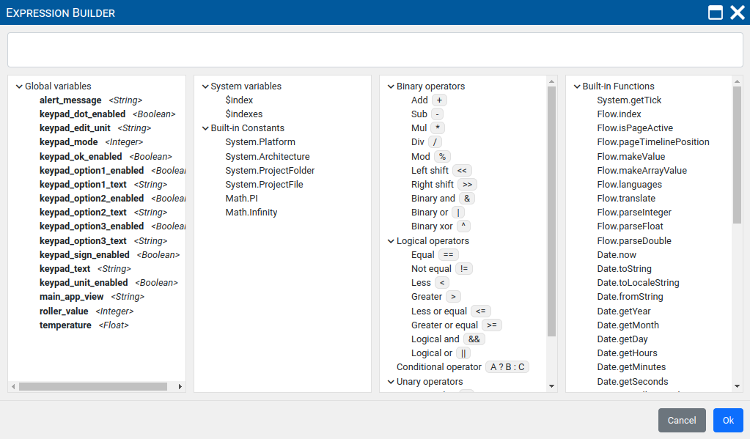Fig. 5: Expression builder

